**1.1 Global View - Device**



**1.2 Global View – AWS IoT and AWS Lambda**



**1.3 Global View – IB/Queue/Custom app overview**



**1.4 Global View – System user/Admin overview**

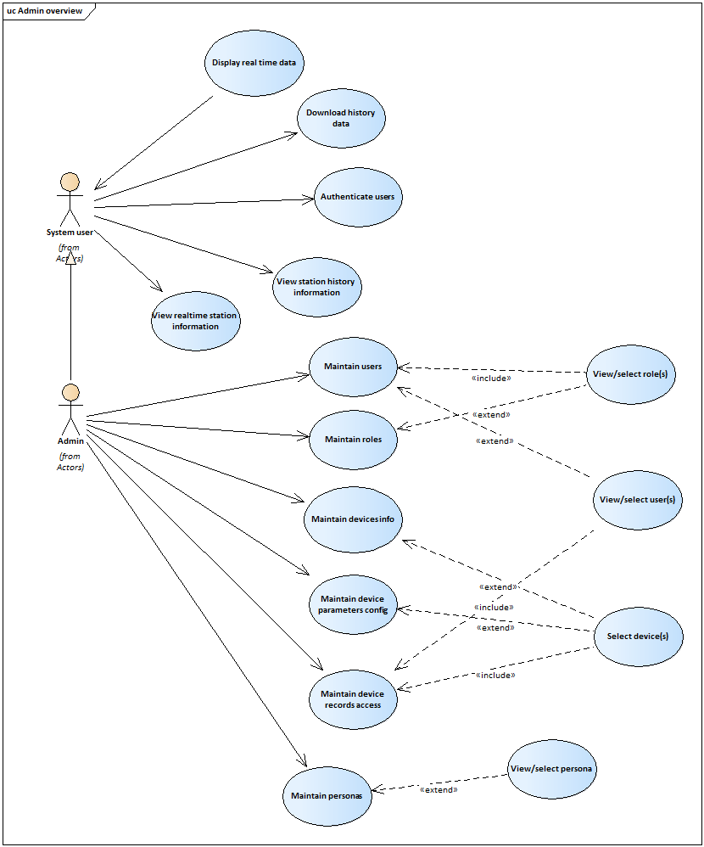

**Actors**

All Actors in the system are contained in this package. This is both as a way to organize the model, making it easier to understand, and to provide a way to manage the actors in a single configuration item. If different individuals are responsible for different actors and their related artifacts, the actors should be organized into their own packages and placed under separate configuration control.

**Device**

This actor represents PV system device which is responsible for sending data to the cloud service. It will also send the device health statistics to the application, which is deployed on the cloud, via Virtual Private Cloud.

**IoT**

This actor represents a cloud IoT service which is to receive the data sent from devices in every second and every minute. And then this will pass the data to another cloud Lambda function to structure the unstructured data.

**Lambda**

This actor represents a server-less cloud function which will receive the data from AWS IoT and transform the data into structured data. After data transformation, both unstructured(original) data and structured data will be passed the AWS Dynamo to store.

**System User**

This actor represents the different type of users(personas) who will monitor the assigned real time data and device health statistics, which will be sent from various devices, in rich user interfaces.

**Admin**

This actor represents the root user who can create and maintain users, roles, devices information, maintain device parameter config and maintain device record access. This user will have other common access that the system user has.

**WebDAV**

This actor represents the WebDAV application which will be hosted on cloud.

**Device Health System**

This actor represents an application which will detect the devices and get the devices health statistics.

**AWS Dynamo**

This actor represents a cloud-based database application.

**Synchronizer**

This actor represents a cloud-based service or a custom application which will receive the data and send the data to the display screen.

**Use cases**

All Use Cases in the system are contained in this package. This is done strictly as a way to organize the model and make it easier to understand.

See Rational Unified Process:

Activity " Describe the Use Case Model".

In order to version control use cases it is recommended to specify use case packages within this package.

Use Cases are often documented in a separate text file, use the Rational Unified Process template or use the use case template in Rational Requsite Pro.

The "Use Case Realizations" that correspond to these use cases are created in the Design Model.

**Authenticate users**

The aim of this use case is to enable users to log-in to the system using a unique username and password. Associated with each username is a system access level which is used to determine the system functions and records that can be accessed. This use case also enables the user to log-out from the system.

**Maintain personas**

The aim of this use case is to enable the administrator to user to create, update, view and delete persona (user group).

**Maintain users**

The aim of this use case is to enable the administrator to create user accounts and grant user roles and assign to the respective persona(user group). Also, the use case enables the system administrator to reset passwords, change access rights and deactivate/activate accounts.

**Maintain roles**

The aim of this use case is to enable the administrator to create user roles which will be assigned to the registered users. The admin can also update the role information in this use case.

**Maintain devices info**

The aim of this use case is to enable the administrator to create, update, view and delete device info in the system.

**Maintain devices parameters config**

The aim of this use case is to enable the administrator to create a configurable setting for each created device. This is to be used in transforming the unstructured data, which will be sent form all devices, into structured data for analysis purposes. This use case will also allow the admin to copy the parameters config as a new set of config for the same kind of device which send the same parameters.

**Maintain devices records access**

The aim of this use case is to enable the administrator to create an access control for each created persona (user group) on the data that will be sent from multiple devices. So that the user will only see the data which is assigned to the persona the user is in.

**View/select role(s)**

The aim of this abstract use case is to enable the admin to view a list of existing roles and select a role from the list.

**View/select user(s)**

The aim of this abstract use case is to enable the admin to view a list of existing users and select a user from the list.

**Select device(s)**

The aim of this abstract use case is to enable the admin to view a list of existing devices information and select a device from the list.

**View/select persona**

The aim of this abstract use case is to enable the admin to view a list of existing personas and select a persona from the list.

**Send data**

The aim of this use case is to enable the PV system device to send the data the to the cloud service in every second and every minute.

**Transform unstructured data to structured data**

The aim of this use case is to transform the incoming data (raw data) into the structured data based on the device parameters config which is created in the “Maintain device parameters config use case.

**Store data**

The aim of this use case is to store both incoming data (raw data) and structured(transformed) data into the cloud database.

**Send real-time data**

The aim of this use case is to send the structured data, after the data transformation in “Transform unstructured data to structured data”, to the “Synchronizer” application.

**Send real-time data**

The aim of this use case is to send the structured data, after the data transformation in “Transform unstructured data to structured data”, to the “Synchronizer” application.

**Display real-time data**

The aim of this use case is to show the incoming data, which will be sent from the “Synchronizer” application, in rich user interface.

**Get device health**

The aim of this use case is to enable the Device Health System to get the device health statistics from the connected devices.

**Send data to WebDAV**

The aim of this use case is to enable all connected devices to send the data to

**Download history data**

The aim of this use case is to enable the user to download the history data from the system for other purposes. The user shall download the data in CSV format from the system based on the date range and selected parameters.

**View real-time station information**

The aim of this use case is to enable the user to view the real-time station information (weather and system health) on the Web Page.

**View station history information**

The aim of this use case is to enable the user to view history record of the stations. The user shall view the history record in various Rich User Interfaces.